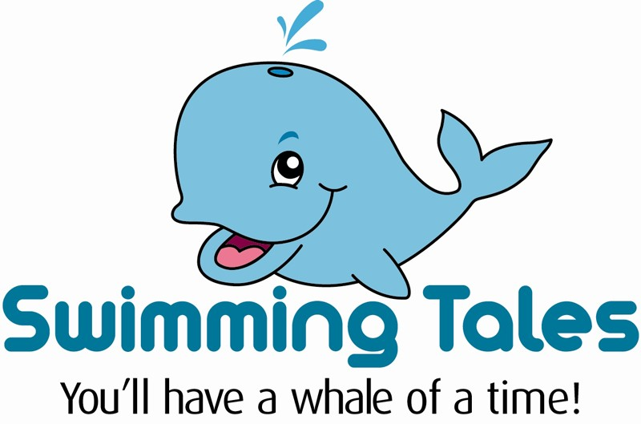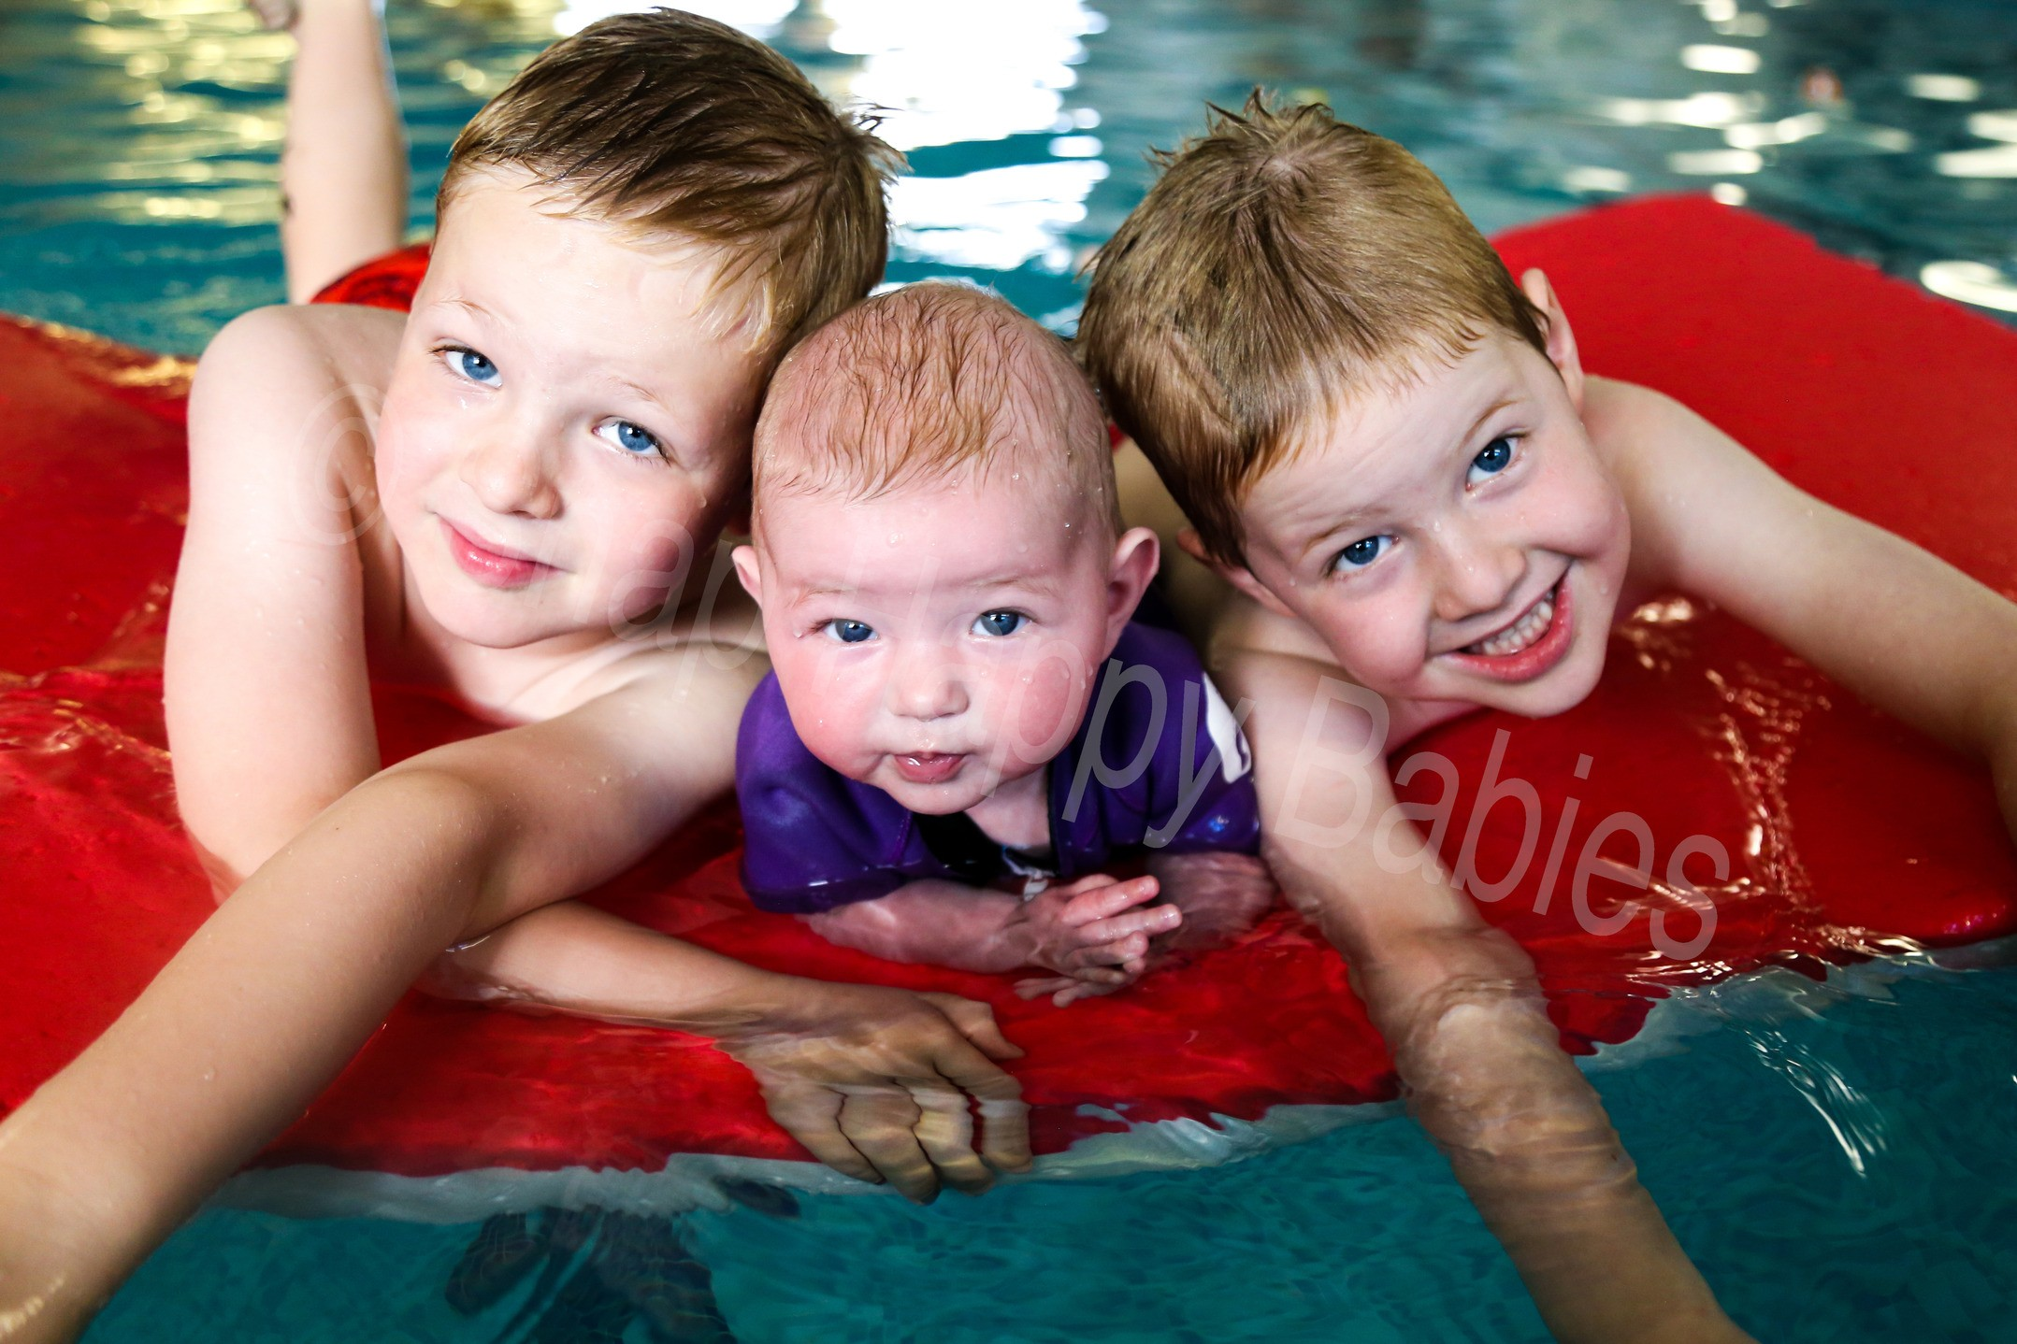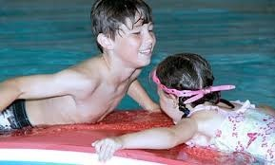

OCTOBER SCHOOL HOLIDAY FUN SWIM ACTIVITIES

Monday 28th October – Sunday 3rd November 2019
CHILDREN'S SWIMMING CRASH COURSE
Learn how to swim or to improve your swimming by attending a half hour lesson every day for one week, Monday to Friday. A fantastic way to give swimming a boost in small classes arranged according to ability.
Cost: £32 members / £35 non-members
Or why not try a half hour PRIVATE 1 TO 1 LESSON tailored to your individual need to help gain confidence or master a technique/skill that you are struggling with.
Cost: £20 members / £21 non-members
FUN SWIMS
Just turn up for some splashing fun with toys is pool toys:
Monday, Tuesday, Wednesday and Friday: 11am - 1pm
Thursday: 2pm - 4pm Sunday: 11.30am - 3pm
Cost: under 3's - Free, Children - £3, Adults - £4.50

ORGANISED FUN SWIM GAMES
Fun teacher led swimming games – 7 yrs plus
Wednesday 3pm - £5/£6 members/non members

UNDER 5'S ONLY FUN SWIM
On Thursday, 12pm to 1pm, we will be holding a fun under 5's play swim with lots of toys to play with and the older kid out of the way!

INFLATABLE FUN
Come and have a 'whale of a time' on our fantastic inflatable on Tuesday 2pm to 3pm or Friday 3pm to 4pm for children 8 to 12 years olds, or for our younger swimmers try out our Pirate Boat inflatable Tuesday 3pm to 4pm or Friday 2pm to 3pm for children under 10 years with parents
Cost: Children £3 (members) £4 (non-members) Adults £2.50

For further details visit: www.swimmingtales.co.uk or call: 01268 786786

